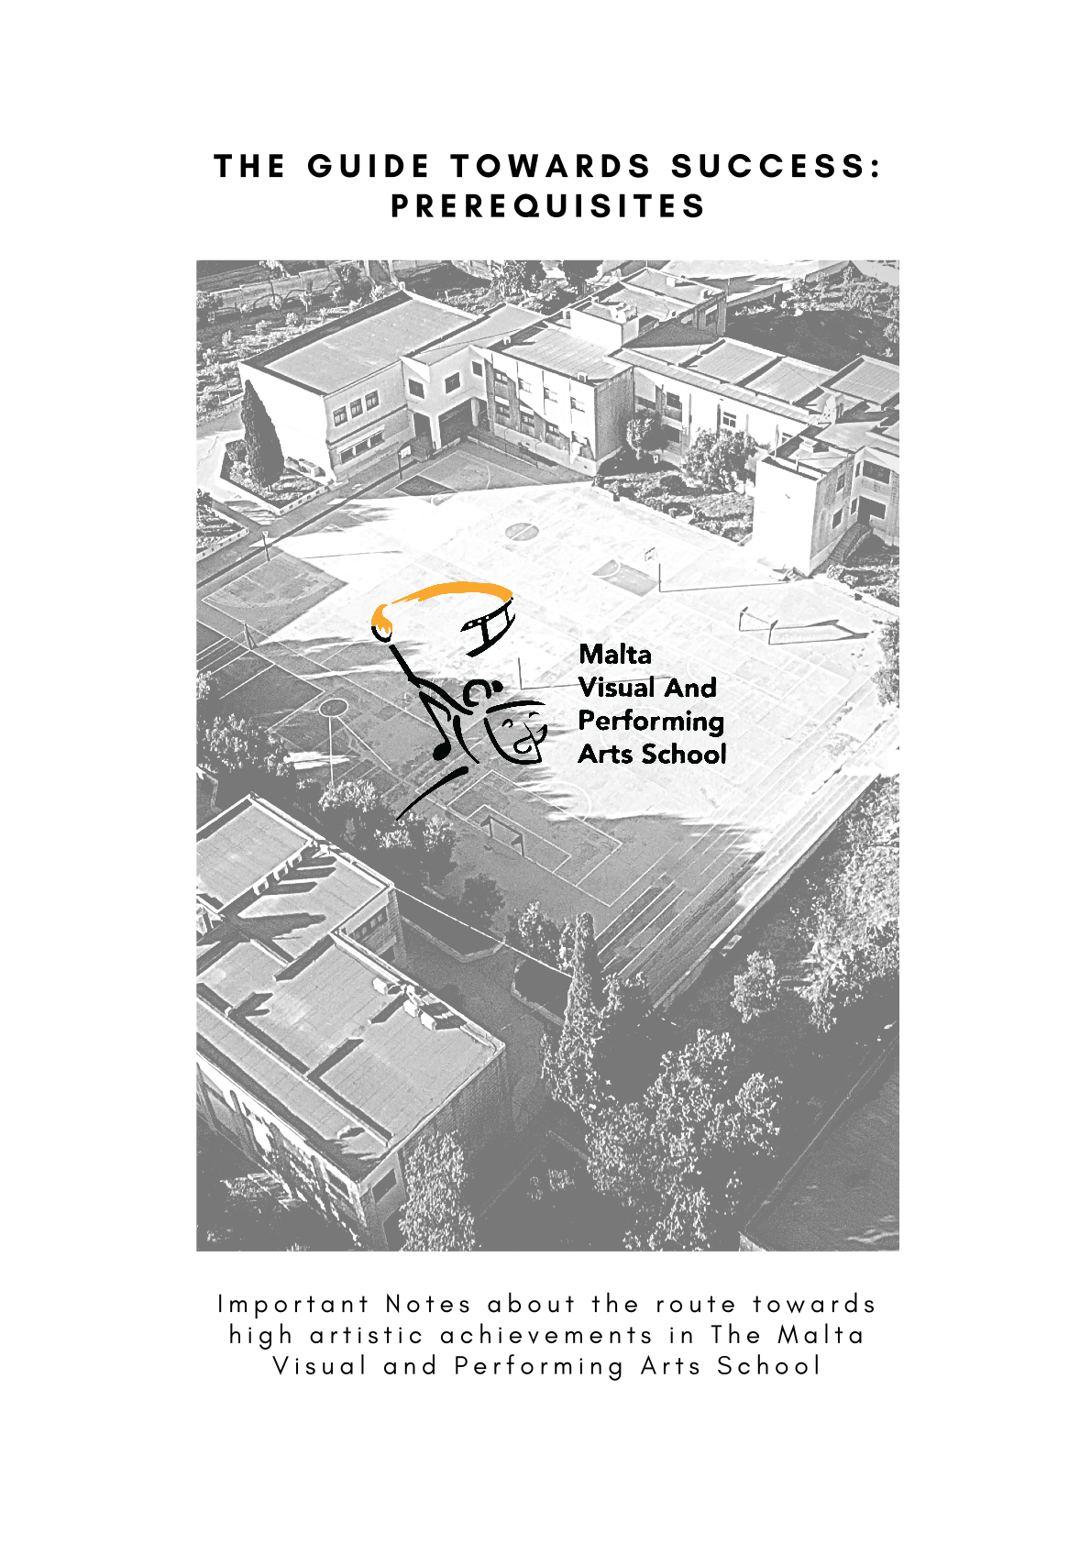
PRELIMINARY NOTES

This document is divided into seven parts, entitled:

PART NO 1: The Five Art Forms pg 4
PART NO 2: The Entry selection process pg 24
PART NO 3: The Entry Requirements for each Art Form pg 28
PART NO 4: The Eligibility and Selection Rules pg 36
PART NO 5: The Data Protection Act pg 38
PART NO 6: Generic Notes about the School Subjects pg 40
PART NO 7: Additional Notes pg 43

These notes are to be read carefully.

The notes provide good indications and suggestions about the route that students can take towards a successful entry to The Malta Visual and Performing Arts School.

Parents/Legal Guardians, who are applying on behalf of the child under their care, have to confirm that they have carefully read and understood the demands of this document as requested by both the online application form and the hard (printed) copy.

VISION STATEMENT

To be a highly regarded, effective secondary school which excels in nurturing the students’ academic, social, creative potential and elicits artistic and cultural contribution.

MISSION STATEMENT

Our school strives to operate as a culturally diverse community of students, parents and staff, dedicated to creating a student-centred learning environment based on respect, trust and collaboration. Every student will be empowered holistically to develop his or her emotional intelligence and critical thinking skills to serve as an inspiration to others in years to come.

Part No 1:
THE FIVE ART FORMS

Study Programmes (Year 7 to Year 11) for the

Five Art Forms

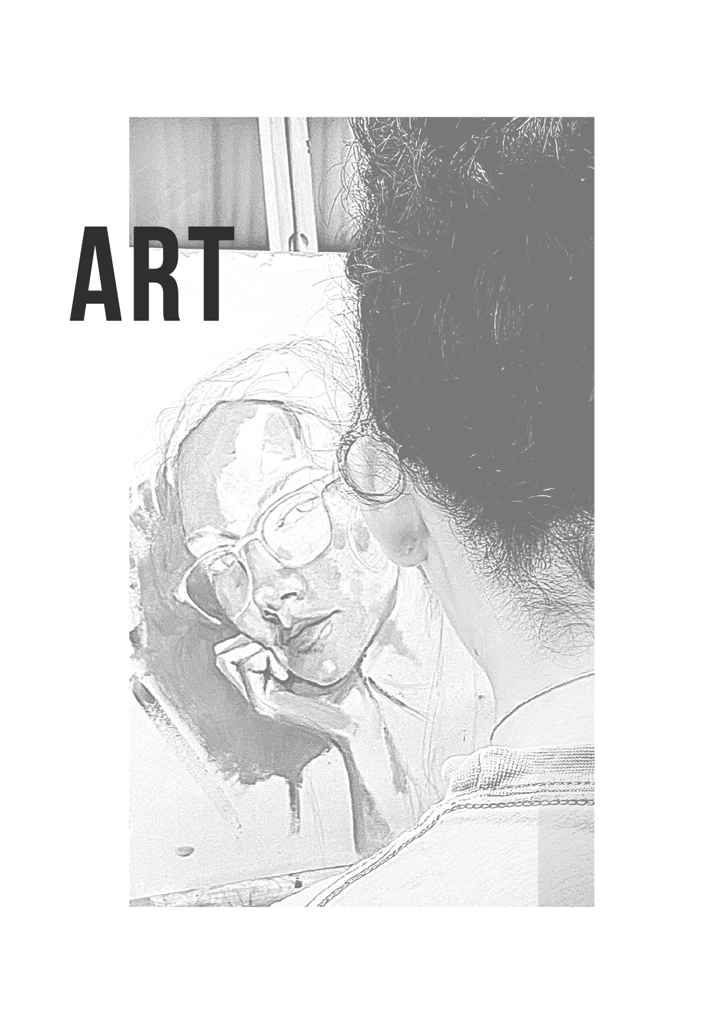
Proposed Subject Tuition in:

- AESTHETIC APPEAL
- PERCEPTUAL ELEMENTS
- TECHNICAL PROFICIENCY
- PERSONAL AND SOCIAL DEVELOPMENT
- HISTORICAL PERSPECTIVE

AESTHETIC APPEAL:
Through Visual Art the students will understand and use the language of aesthetics, which is beautiful, artistic and carefully crafted with a poetic element of narration in the art pieces. This will enable them to comprehend the nature and function of the art form. They will understand better their work, and that of others, within the context of their environment and culture.

PERCEPTUAL ELEMENTS:
The students will be presented with the prospect of nurturing the perceptual skills needed to understand and respond to Art and Design forms. They will learn to respond to the visual environment through visual, tactile and sensory experiences.

TECHNICAL PROFICIENCY:
The students will be taught how to develop and improve the necessary skills involved in the handling of different tools for the manipulation of different materials in the creation of art pieces in different media.

PERSONAL AND SOCIAL DEVELOPMENT:
The quality of the students learning will be enriched since these subject challenges their abilities to imagine, think, perceive, take decisions, create, and strive to disentangle and then to solve problems. It heightens and improves their view of the world and their reactions and responses to it.

HISTORICAL PERSPECTIVE:
Anything that is designed by human beings exhibits visual qualities that are specific to the place and period in which it originates. This study aims to give a historical understanding of the origins of artefacts within specific world cultures. This entails asking about the circumstances of their making, their creators, the media used, the functions of the images and objects, their critical reception and their subsequent history.

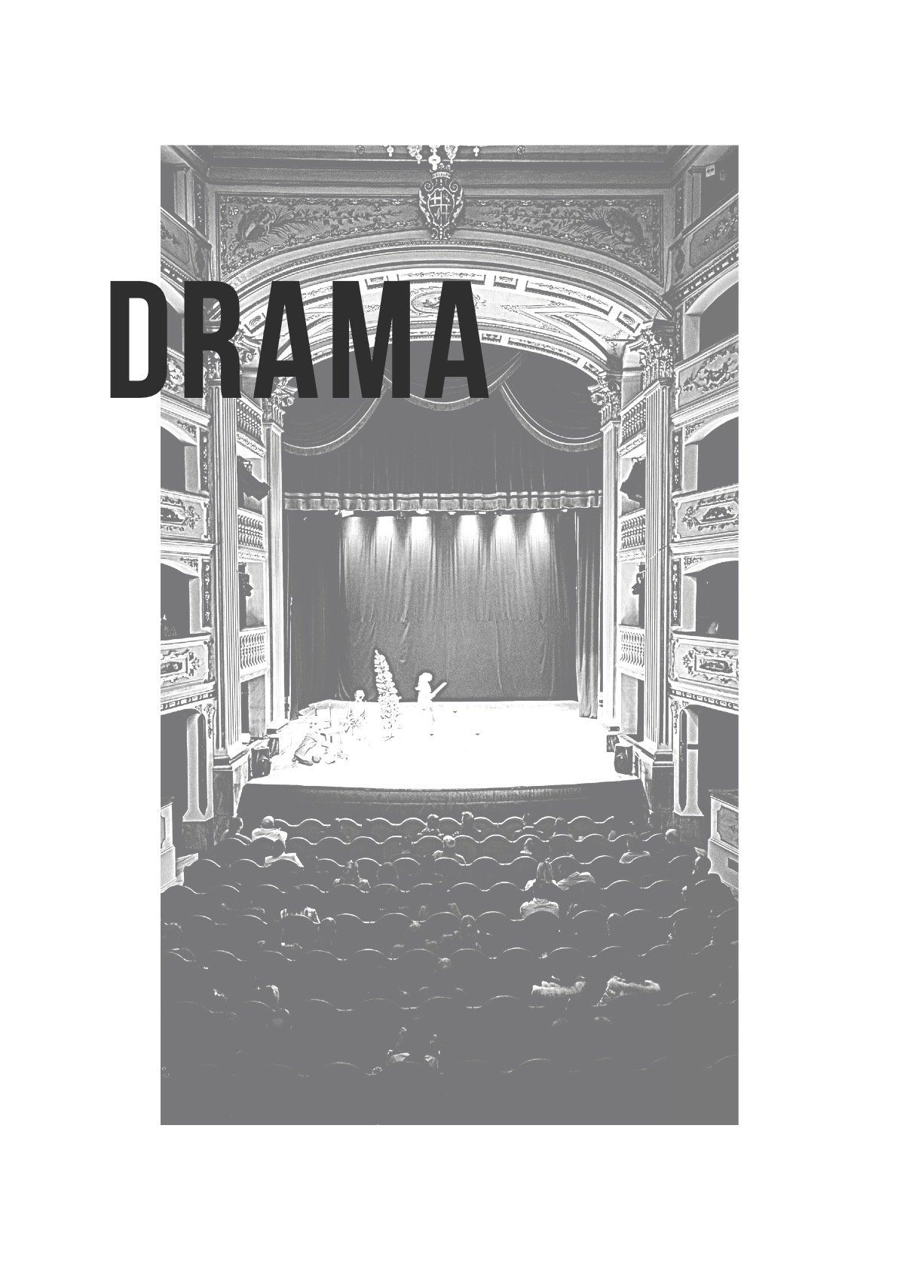
Proposed Subject Tuition in:

- CHARACTERIZATION
- EXPRESSION
- HISTORY
- ANALYSIS
- ACTING
- DEVISING THEATRE

CHARACTERIZATION:
The students will learn to identify, to explore and will also learn how to “create people”. From probing known characters they will move to creating and building unknown ones. Moving from script to performance and beyond, they will learn to animate the character including habits and traits. Also to bestow the character with history through thought, speech, mannerisms, body language and physical appearance, action, interaction and reaction.

EXPRESSION:
Body Language and Voice are two essential components in an actor’s tool kit box. The students learn how to interpret a character, how to deliver a message and how to express emotions. They will be guided through both verbal and non-verbal modes of expression, thus transporting them from mime to Greek chorus, onto musical theatre. Thus, they will study song interpretation for the stage to further their knowledge of character development.

HISTORY:
Students will research how the historical heritage of the theatre got was assembled through the ages. They will study how social, religious, and economic needs and even war led into the conversion of ceremonial rituals and celebrations into cultural upshots. They will learn how the creation of different genres and styles of Theatre came about. They will also be thought to identify, describe, and compare global historical characters and situations in drama.

ANALYSIS:
The students will work on developing their analytical skills that will help them look at and evaluate different theatrical performances. Then use this critical analysis to create new perspectives. They will learn to reflect on the use of language, scrutinize dialogue structure, evaluate the depth of various characters in a dramatic piece, and explore the possibilities of different endings. They will be guided to use common sense and discretion in criticism.

ACTING:
Students explore acting techniques through understanding and activities. They indulge in improvisation and practice stage movement, both individually and in ensemble performance work. Working on scenes from modern, children, and classical theatre, through farce, comedy and tragedy, they will be given space to explore how these techniques differ for the stage, for the camera, for radio plays, and so on.
DEVISING THEATRE:
Students will learn to collaborate with others as a team. Together, they create scripts, probe into methods of how to produce and direct plays and how to market them. They detect theatrical styles and notice what influences artistic choices. They will acquire basic backstage management skills in costume, set, and prop making. They will also be exposed to simple operational practices in stage, sound and light,. Through this, they learn to create patterns, plans and drawing, both for light and sound plots.

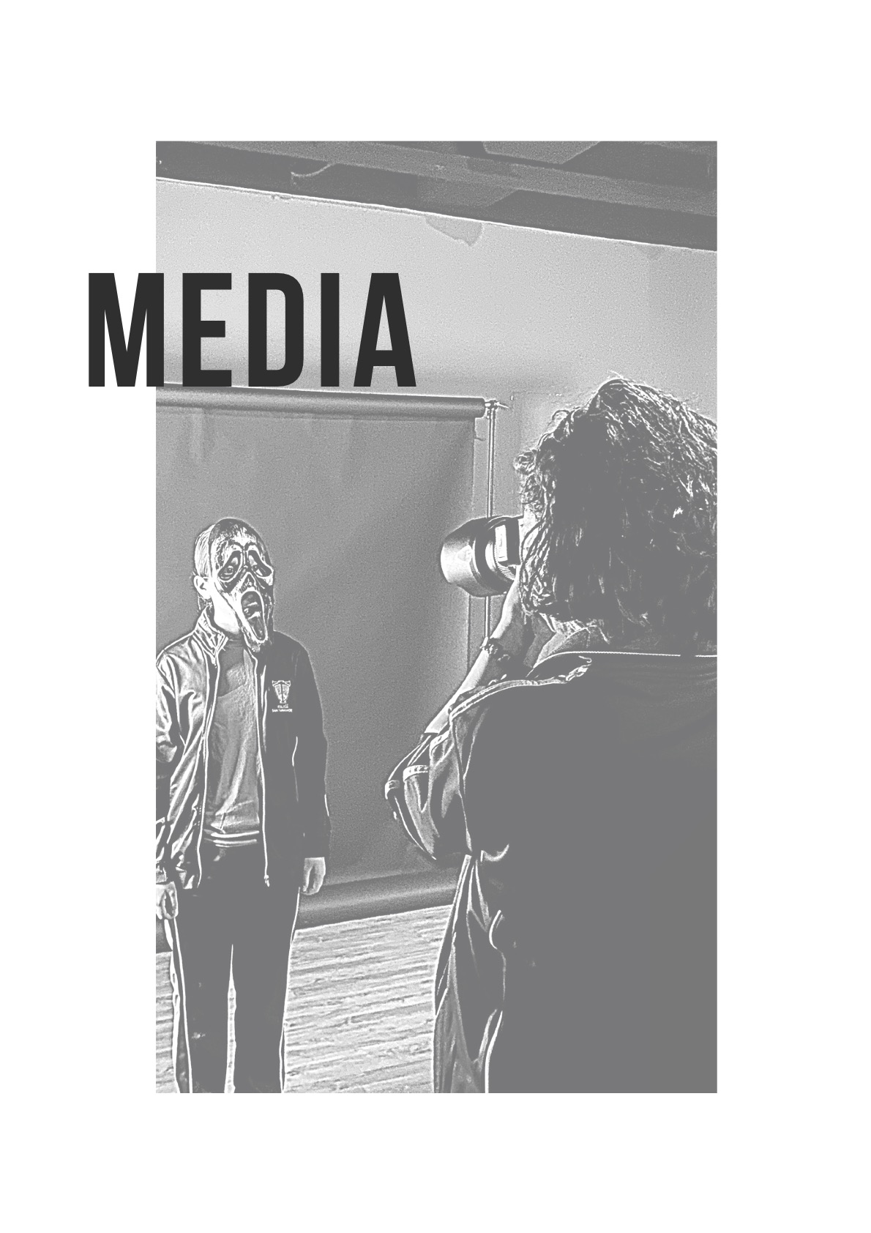
Proposed Subject Tuition in:

- PHOTOGRAPHY
- VIDEOGRAPHY
- GRAPHIC DESIGN
- WEB DESIGN/ DEVELOPMENT
- AUDIO & RADIO
- MEDIA LITERACY & ETHICS

PHOTOGRAPHY:
The coursework will introduce the art of photography and all the technical skills associated with it. Students will be introduced to the use of lighting techniques, handling of a camera as well as a multitude of different styles and photographic techniques. They will also be introduced to the world of photo-re-touching and manipulation, leading to presenting their artwork in a professional manner.

VIDEOGRAPHY:
This section focuses on good video camera handling and framing techniques, planning a storyboard for a video, as well as filming and editing. Learners will also understand the production process of TV shows, films, and live broadcasting. They will be discussing and analysing special effects and motion graphics.

GRAPHIC DESIGN:
Explore the basics of graphic design, including visual composition rules, typography, and tie them to the printing production process that students will be familiarised with. They will learn the basic principles of designing posters and other promotional material as well as using typographic layouts. They will also be led through the process of corporate identity

WEB DESIGN/DEVELOPMENT:
This is an introduction to web design, which deals with the skills to create and to use blogs as well as using social media as a platform for promoting their creative work. Basic web development skills will be also taught.

AUDIO (AND RADIO):
This topic will introduce the students into the realm of recording and of the manipulation of audio and prepares them to use audio competently in video production. Several professional industries tied into audio production will also be discussed, most notably that of radio.

MEDIA LITERACY & ETHICS:
This stream will instruct students how to correctly interpret the media that they are exposed to, and as a natural extension, they learn how to produce it themselves. In addition, they will be instilled with values that will help them wield their creative power responsibly, criticise and evaluate information online. Thus, avoiding spreading misinformation or causing harm.

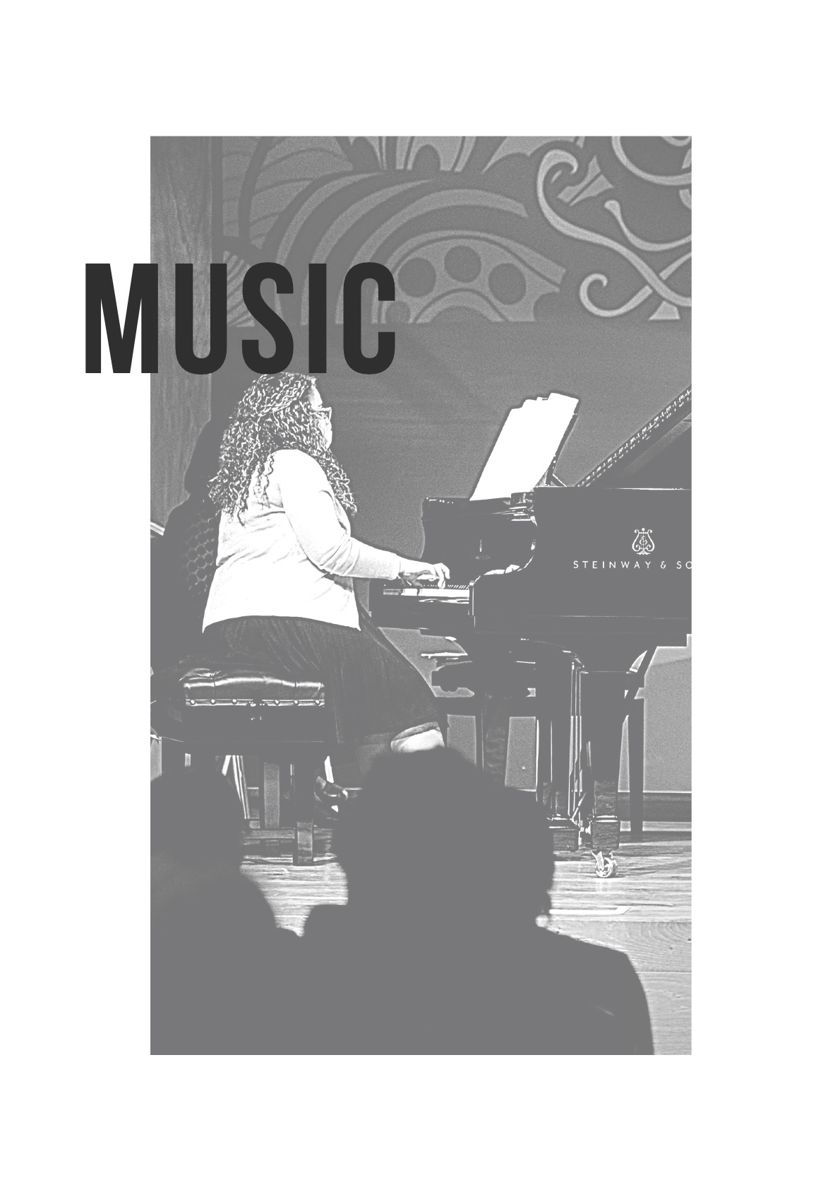
Proposed Subject Tuition in:

- PERFORMANCE- THE STUDY OF THE INSTRUMENT OF CHOICE/ VOICE ENSEMBLE AND CHOIR
- MUSIC THEORY
- HISTORY OF MUSIC, LISTENING AND APPRAISING
- MUSICIANSHIP, SIGHT READING AND SOLFEGGIO
- COMPOSITION AND DIGITAL LITERACY
- ONGOING CREATIVE PROJECTS AND CONCERTS.

Proposed Instruments*:

- Piano
- Violin
- Viola
- Cello
- Double Bass
- Trumpet
- Horn (F)
- Bb Baritone
- Euphonium
- Recorder
- Bassoon
- Guitar classical
- Electrical guitar
- Trombone
- Tuba
- Saxophone
- Flute
- Oboe
- Clarinet (in B flat)
- Drum kit
- Accordion
- Harp
- Voice- Classical and Musical theatre only

* All instruments are available only subject to teachers’ availability.

PERFORMANCE:
Each student is offered a weekly double lesson on an individual basis in the instrument of their choice/ voice. All students in the school study in different ensemble combinations, from smaller groups to larger and more varied ones in scheduled weekly lessons. All students in years 7 and 8 study choral and basic vocal technique.

MUSIC THEORY:
Students study music theoretical concepts, to understand better the fundamentals of music.

HISTORY OF MUSIC, LISTENING AND APPRAISING:
Students explore the music from different periods of music history. They will listen to and learn about the development of musical styles of vocal and instrumental music, focusing also on some works of major composers.

MUSICIANSHIP, SIGHT READING AND SOLFEGGIO:
Students develop their inner hearing skills, music reading skills and musicality in general to have a better understanding of the music they are performing.

COMPOSITION AND DIGITAL LITERACY:
This course intends to stimulate the students’ imagination and enhance their inventive capabilities. They will acquire knowledge and skills to be able to create their own original music. Students will use different technology and music computer programmes to explore sounds and composition techniques.

ONGOING CREATIVE PROJECTS AND CONCERTS:
Being a dynamic school, students are invited to participate regularly in creative projects and concerts. These will help develop their creativity, motivation, performance etiquette and self-confidence as well as their artistic entrepreneurship skills. Students promotes interlinks with other art form subjects.

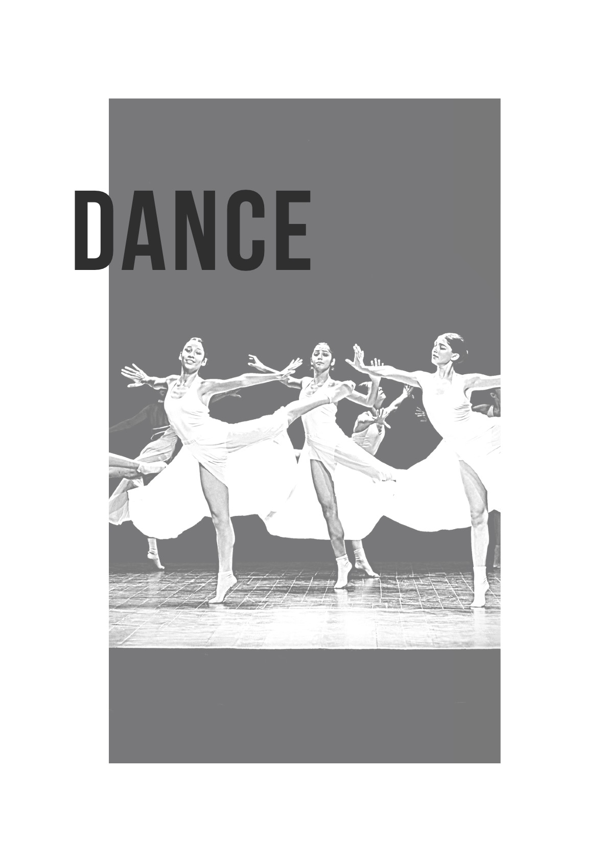
Proposed Subject Tuition in:

- BALLET
- MODERN TECHNIQUES
- THEORY

BALLET:
This course is designed to provide a solid grasp of the technical requirements of classical and neo-classical ballet. It is intended to nurture and enhance the students’ artistic and technical development in the dance genre.

MODERN TECHNIQUES:
This is a study of the major contemporary styles including Release-based, Cunningham, and other modern theatre techniques, which all contribute to the overall development of the dance student.

THEORY:
This course will develop a basic understanding of the contextual and theoretical frameworks in dance. Topics covered include Analysis, Critique, Anatomy, Dance History, Dance Devising and Choreography Techniques.

Part No 2:
THE ENTRY SELECTION PROCESS

The measure with which the Applicant will be assessed and eventually chosen

Summary of the filtering selection system in 2 stages which are divided into 2 parts.

STAGE ONE: 1st Part: Refer to MVPA Guidelines for Parents -
the respective Art Form requirements
(Pages 28 – 35)

STAGE TWO: 2nd Part: ACADEMIC RESULTS 50% of the Global
Annual mark

Note:
Each student must achieve at least 50% in three of the four core subjects: Mathematics, English, Maltese and Science.
Marks are calculated using a 60% summative and 40% formative assessement per subject.

STAGE ONE: 1st PART - ART FORM

DRAMA, MUSIC, DANCE:
REFERRAL: certificates and letters of recommendation from recognised entities, and such evidence may be verified by the Selection Board.
AUDITION: a short performance that tests the Applicant’s artistic skill.

ART
PORTFOLIO: a collection of TEN (10) drawings, representative of the student’s achievements and skills, compiled over a period of time under the guidance of their Art teachers and accredited by them as Referees with a signed declaration, and such declaration may be verified by the Selection Board.
PRACTICUM: a hands-on 2-hour session during which students produce one artwork.

MEDIA
INTERVIEW: a short cross-examination during which the students give substantial proof that they have a genuine interest in Media.

Disposition:
FORMAL CONSULTATION: an oral enquiry to evaluate the student’s temperament and personal characteristics, as well as their propensity for the chosen art form. This interview will be conducted in the presence of Parents/Legal Guardians.

STAGE TWO: 2nd PART - ACADEMIC RESULT: 50% of the global mark.

ANNUAL RESULT
SET OF STANDARDS: The classification method employed to establish performance rating in Maltese, English, Science and Mathematics at the end of Year 6.
Note: Stage TWO- 2nd part
- The process starts from the top name (the highest placed) of the interim classification list and moves down according to the placing.
- Provided that students obtain 50% or more in three of the core subjects: Mathematics, English, Maltese and Science of the Annual Results. The best ten (10) students in each of Art, Dance, Drama, and Music and the best eight (8) students in Media, will be successfully admitted to the school.

PART NO 3:

THE ENTRY REQUIREMENTS FOR EACH ART FORM

Details of the selection procedure in ART.

Art requires Standard of Proof which should be clear and convincing. Students opting for this art form must provide evidence that they have the required standard, obtained from their Art teacher in class during their last scholastic year, as is specifically demanded hereunder. Students who don’t provide such Standard Of Proof will be at a severe disadvantage.

PORTFOLIO:
The students display a collection of ten (10) artworks, showing a variety of materials, techniques and subjects of their choice. These can be a selection of 2D and 3D works. They are to demonstrate an ability to talk about the process of creating any one of their Portfolio works and the purpose or intention behind it. All ten pieces presented have to be signed at the back of each artwork by the Art teacher at the school as indicated in Part 7 of this document, as proof that they are genuine pieces made by the students. Works that show the intervention of others will not be considered. Also, copies of artworks and/or images (from the internet or other references) and works that are heavily influenced by the work of others will not be considered.

There is no need to bring a reference letter.

PRE SELECTION PROCESS - ART
We have a pre selection process for Art form students. The selection process is based on two (2) parts; (i) the practical session and (ii) the interview.
In the first part, the examiners observe the candidate’s artistic techniques, and overall knowledge. The ability to manage structure, form, shading, and color, to complete an artistic composition.
The candidates who are successful in the first part, i.e. in the practical session, move on to the second Part of the selection process. This pre-selection exercise enables the board members to choose the best 25 students who have shown good skills and artistic talent in their produced work. These students will then sit for the interview.

PRACTICAL SESSION:
- The students will draw/paint/sculpt something of their choice, in a 2-hour hands-on session, using any materials, also of their choice.

- A number of starting points (themes and/or objects) are given to the learners. From the starting points, one can produce a 2D or 3D work.

- The teachers supervising the session will see that the students do not copy directly from pictures that they are allowed to bring with them as resources, or preliminary studies, or preparatory work.

- The participants have to provide their own materials: papers, papers for collage, scissors, glue, paints, pencils etc. or materials to create a 3D work. If needed easels will be provided on-site.

- The participants can produce more than one work. Sketches and other preparatory work should be handed in with the final work.

- The session will be well supervised and proceedings well monitored.
Criteria: (A total of 100 marks)

- Use of Materials and Techniques: technical skills.
- Creativity and Imagination: creative process.

INTERVIEW.
Criteria: (Total of 30 marks)
- Portfolio Presentation: the ability to talk about their art.
- Portfolio Contents: a variety of materials, techniques and subjects.
- Personality.

Details of the selection procedure in DANCE.

Dance requires Standard Of Proof which should be clear and convincing. Students opting for this art form must provide evidence that they have the required standard, obtained in grades from recognised institutions, as is specifically demanded hereunder.

REFERRAL: Standard of Proof that can be found at the end of this document.
Refer to Part 7- ADDITIONAL INFORMATION.

AUDITION:
In an ensemble, the students will dance a classical routine (ballet) to an accompanying piece of music selected by the auditioning members. This will take from 1hr15min to 1hr30min.

Students will be assessed in the following four areas:

- Technique and Facility
- Artistry
- Musicality and Rhythm
- Quality and Coordination of Movement.

INTERVIEW:

- Personality and knowledge of the Art form.
- Presentation of Portfolio

Details of the selection procedure in DRAMA.

Drama requires Standard Of Proof which should be clear and convincing. Students opting for this art form must provide evidence that they have the required standard, obtained in grades from recognised institutions, as is specifically demanded hereunder.

REFERRAL: Standard of Proof that can be found at the end of this document.
Refer to Part 7- ADDITIONAL INFORMATION.

AUDITION: The students will act out, in their manner and style, one narrative that they choose from the four pieces presented in the section ADDITIONAL INFORMATION.

(Applicants are duly informed that should they wish to choose a Maltese version of any one of these four pieces, they can find them on pg 46).

They will repeat the same piece under specific directions from one of the auditioning members. They will have to convert the narrative into direct speech between two characters and act out a two-hander with the use of two puppets. Finally, they will have to interpret one sentence from the narrative in four given moods chosen by one of the Selection Board members.

Details of the selection procedure in MEDIA.

Media does not require any Standard Of Proof. However, students will have to provide a solid proof of a genuine interest in Media, as well as a keen eye for detail in their everyday experience of Media.

AUDITION:
Students will be selected via a twenty minute interview. Media is an art which requires different competences and pull. Scriptwriters, costume designers, graphic designers, animators, photographers, storyboard artists, camera operators, and directors all need such different skills which are all important within the vast world of media.

Details of the selection procedure in MUSIC.

Music requires Standard Of Proof which should be clear and convincing. Students opting for this art form must provide evidence that they have the required standard, obtained in grades from recognised institutions or presenting the necessary work as is specifically demanded hereunder.

REFERRAL: Standard of Proof that can be found at the end of this document.
Refer to Part 7- ADDITIONAL INFORMATION.

 
AUDITION: FOR ALL STUDENTS.

All students will sit for an audition which will include:

- Performance: Students will perform three (3) prepared pieces of their own choice. Students are to bring their own instrument with the exception of piano, drum kit, harp and percussion. Voice students are to prepare three songs from the classical and/or musical theatre repertoire.

- Sight Reading: Students will play one (1) piece by sight.

- Aural Test: During this test:

- Students will be asked to repeat a rhythm played twice.
- Students will sing a short phrase (melody) within a range of an octave played twice.
- Students will listen to a musical excerpt and will be asked to comment on its
musical characteristics.

The Theory paper will be held on another date.

Students requiring an accompanist must provide their own pianist. The board will not provide an accompanist.

THEORY
Theory paper 80 marks
The children will sit for a theory exam one month before the audition. The exam paper will be at a level comparable to Grade 1 and Grade 2 standards. The duration of the exam will be 1 hour. Those failing to get a 50% mark will not be selected for the audition.
AUDITION
Performance 60 marks
Piece 1 20marks
Piece 2 20marks
Piece 3 20marks

Each examiner evaluates the student’s performance and gives a mark for each piece performed. The average mark is then calculated.

Marks are given on musicality, playing in style, intonation, flowing tempo, accurate rhythm and observation of expressions and articulations.

The maximum mark can be achieved if the pieces presented are at Grade 2 level or above and are played without mistakes. If a selected piece is at Grade 1 level, the maximum mark should not exceed 10 marks.

Sight Reading 20 marks
Full marks are obtained if the student performs the given piece without mistakes, played at a flowing tempo, accurate rhythm, observing expressions and articulations included.

Aural & Listening 30 marks
Clapping a rhythm 7 marks
Singing a melody 7marks
Questions on piece 16marks

Students will be asked to comment on the mood, dynamics, articulation, clapping of pulse and identification of time signature.

Aptitude / References 10 marks
This mark is based on the child’s musical interests and experience. Any exam certificates, awards or participation in concerts should be included in a portfolio and presented during the audition.

FINAL MARK
Total mark 200 marks
The final mark will include the theory paper mark and marks obtained during the audition.

PART NO 4:
THE ELIGIBILITY AND SELECTION RULES

Details of the rules and regulations that define the Eligibility and the Selection Process

- ELIGIBILITY (Right to Apply)

- The Application for entry in The Malta Visual and Performing Arts School is open to
all Year 6 students, State and non-State schools in Malta and Gozo.

- Parents/Legal Guardians need to consider properly whether their children have the right qualities such as the resiliency and discipline that these subjects entail to
be eligible for entry.

- Applicants who do not have an adequate proficiency in the Maltese and English languages, (in reading, writing and understanding) are likely to experience particular difficulty with the coursework and the examinations.

- SELECTION RULES (Filtering System)

- Parents/Legal Guardians, who apply on behalf of the child under their care, must honour the appointments given to them (dates and times) for auditions and interviews.

- Parents/Legal Guardians must understand and agree that they have to stand by all decisions that are taken in the selection process, by the relevant Selection Board.

- The decision of the Selection Board is deemed as final.

PART NO 5:
THE DATA PROTECTION ACT

The Data Protection Act (Cap 440 of the Laws of Malta) regulates the handling of personal data held both in electronic and in hard copy form. The school is required to fully comply with the Data Protection Principles as set out in the Act in accordance with the General Data Protection Regulation and SL 440.09.

  - In order to carry out its functions, The Malta Visual and Performing Arts School, within the Ministry for Education and Employment, collects, processes and keeps on its books personal data, in order to comply with the legal obligations under the Education Act (Cap 327 of the Laws of Malta) and also all other statutory provisions. The school does this with the utmost discretion.

  - Employees of this Department, who are assigned and obliged to carry out the functions of the Department, can access the information that Parents/Legal Guardians give.

  - Some details of the personal data may also be disclosed to other government
departments and third parties, such as hospitals, clinics, and other medical specialists, if and when an Applicant needs medical care. The Education authorities may also have access to this data as authorized by law.

  - Details related to Applicants and Parents/Legal Guardians are mandatory for the selection process and are requested once the applicant applies for admission to attend this school.

  - After the successful admission of Applicants to the school, personal details belonging to Parents/Legal Guardians become essential for the smooth running of the school.

  - An Applicant’s records may also include a photograph for which a separate consent will be requested from the Parents/Legal Guardians.

  - Parents/Legal Guardians are required to inform the school instantly of any changes to the registration details of the Applicant. Such information needs to be kept up to date.

  - All individuals whose personal details are on the School’s books are entitled to know what information the School has, as well as, the manner in which such information is used.

  - A request to access this information may be submitted in writing to the Head of School and duly signed by the Parents/Legal Guardians.

PART NO 6:
THE GENERIC NOTES ABOUT THE SCHOOL SUBJECTS

The Visual and Performing Arts School puts significant weight on the teaching of the five art forms. However, much attention have been afforded to other subjects, thus giving a balanced combination of the five Art Forms and traditional areas of study as proposed by the National Curriculum Framework.

Information regarding subject lessons for Year 7 (Form 1) and Year 8 (Form 2).
Learning Area | Subject | 40-minute lessons per week
Languages | Maltese | 5 lessons
Languages | English | 5 lessons
Languages | Foreign language | 3 lessons
Mathematics | Maths | 5 lessons
Science &Technology | Integrated Science | 4 lessons
Science &Technology | ICT | 1 lesson
Health & Physical Education | PE | 1 lesson
Religious and Ethics | Religion/Ethics | 2 lessons
Humanities & education for Democracy | Geography | 1 lesson
Humanities & education for Democracy | History | 1 lesson
Humanities & education for Democracy | Social Studies | 1 lesson
Humanities & education for Democracy | PSCD | 1 lesson
Visual and Performing Arts  School- based choice | Art  Drama  Dance  Media  Music | 10 lessons  8 lessons/week for each of the chosen Art Form  2 lessons/week for all the other Art Forms on the rotation basis during the year
TOTAL |  | 40 LESSONS

Information regarding subject lessons for Year 9 to Year 11 (Form 3 to Form 5).
Learning Area | Subject | 40-minute lessons per week
Languages | Maltese | 4 lessons
Languages | English | 5 lessons
Languages | Foreign language | 3 lessons
Mathematics | Maths | 5 lessons
Science &Technology | Core Science/Physics/Chemistry/Biology | 4 lessons
Science &Technology | ICT | 1 lesson
Health & Physical Education | PE | 1 lesson
PSCD | PSCD | 1 lesson
Religious and Ethics | Religion/Ethics | 1 lesson
Education Humanities | Humanities | 3 lessons
Visual and Performing Arts Subjects | Art-form subject chosen at Year 7 level:  Art Drama Dance Media Music | 8 lessons
School- based choice | One option subject staring at Year 9 level. Subjects offered at our school are:  - Art Forms  - Sciences  - Technical Subjects  - Humanities | 4 lessons
TOTAL |  | 40 LESSONS

Part NO 7:
ADDITIONAL INFORMATION

This information is meant for those who choose DRAMA, MUSIC and DANCE and ART.

PLEASE SCROLL DOWN WELL

Download and keep in your portfolio. Complete the section corresponding to your area of interest.
Principal’s Office, Attention: Ms Jeanette Debono
St. Thomas More College, Contact No: 25986039
Santa Luċija
Triq il-Kaħwiela
Santa Luċija SLC1831

INFORMATION REGARDING DRAMA

Read well, fill and send

REFERRAL:
Drama School: Name and addresses of accredited drama schools, dates and hours per week attended, starting with the current engagement.

Name and Address of Drama School Dates Attended Hours per week
____________________________________________ _____________ ____________
____________________________________________ _____________ ____________
____________________________________________ _____________ ____________
____________________________________________ _____________ ____________

PORTFOLIO:

Training to Date: Listing of previous drama training until the present. Kindly attach all
relevant examination reports/certificates.

Area of Study YES NO Most recent examination sat for. Examining board,
level, date, taken and result.
Ensemble Performance ___ ___ ________________________________ _________________
Solo Performance ___ ___ ________________________________ _________________
Musical Theatre ___ ___ ________________________________ _________________
Character ___ ___ ________________________________ _________________
Other (Please State) ___ ___ ________________________________ _________________

INFORMATION REGARDING DRAMA
Choose one and prepare it for the audition

You can choose a piece in Maltese or in English

English

SKAR
I never thought hyenas could be useful. They need convincing. But pride appeals to them. I told them to be prepared for a chance of a lifetime; to welcome in the shining new era I had in mind. They couldn’t figure their roles in my circle of life, so they were ready to follow. I was to become their teacher. They asked all about what was to be done and how to get there. I caught their attention. Then I mentioned the death of the King. They were going to! Yes!

URSULA
Fortunately, I know a little magic, and I use it on behalf of the miserable, the lonely, and the depressed who live in pain and need. For example, one girl came to me longing to be thinner. Another guy wanted to get a girl. They were made a perfect match with the help of some magic. As it happened, a couple of times some couldn't pay, and I had to be strict. I've had the odd complaint. But, on the whole, I've been a saint!

BELLE
I come from a little town … a quiet village, full of little people. Every day is the same, starting with greetings of Bonjour! I love to go to the bookshop … almost every day. On my way, I meet the baker carrying the same old bread and rolls … people are gossiping around on what happened. The farmer recently is taking his produce to the market while the tailor opens his shop, and everybody is happily greeting everybody with Bonjour!

ALADIN
Dear friend, I must struggle to make ends meet. I have to eat to live. I have to steal to eat. I live my life, one trick ahead of disaster, one swing ahead of the sword. I steal only what I can't afford. I go in and out of trouble easily. I have many enemies, and beside me, I have Abu, my pet monkey as a friend. Many say I hit bottom ... some call me street rat, others call me scoundrel, and dare to blame my parents and upbringing, except I haven’t got parents!

Malti

SKAR
Qatt ma ħsibt li l-hyenas jistgħu ikunu daqstant utli! Kelli bżonn nikkonvinċihom. Imma l-kburija tappella għal kulħadd. Għidtilhom biex ikunu lesti jieħdu opportunità ta’ darba, li jħaddnu ż-żmien ġdid li se jżernaq. Ma fiehmux x’kien mistenni minnhom, imma kienu lesti jimxu warajja. Sirt l-għalliem u l-kap tagħhom. Kellhom ħeġġa kbira u elf mistoqsija. Irbaħthom meta semmejtilhom li se jmut ir-Re, u huma kienu se jiktbu u jitniżżlu fl-Istorja.

URSULA
B’xorti tajba jien kapaċi nagħmel il-maġija. Nużaha biex ngħin lil min hu fil-bżonn, lil min iħossu waħdu u jgħix ħajja nieqsa minn kollox u mimlija uġigħ. Pereżempju, l-aħħar darba ltqajt ma’ tfajla tixtieq tirqaq, u ġuvni jfittex tfajla. Bi ftit maġija laqqajthom u nġibdu lejn xulxin. Veru li ġieli kien hemm każi fejn kelli nkun iebsa ma’ min ma jħallasx. U forsi ġieli smajt min gerger kontrija wkoll. Imma fil-biċċa l-kbira min jafni jagħmilni qaddisa!

BELLE
Twelidt f’belt żgħira, kwieta u minsija, mimlija b’karattri komuni. Kuljum, kulħadd jisbaħ bi tbissima u t-tislima: Bonjour! Kważi kuljum filgħodu mmur sal-ħanut tal-kotba. Inħobb naqra! Mattriq dejjem niltaqa’ mal-furnar iġorr il-ħobż, xi nies iseksku fuq laħħar ġrajjiet, il-bidwi ġej bil-ħaxix mill-għelieqi biex ibigħhom, u l-ħajjat jiftaħ il-ħanut biex jibda l-jum tax-xogħol. Li hemm komuni hu, li kulħadd jitbissem u jsellem: Bonjour!

ALADDIN
Ħabib, ma nafx tifhimnix. M’għandix ħajja faċli. Biex ngħix irrid niekol, u biex niekol irrid nisraq. Ħajti ngħixha fuq xifer l-irdum, kważi bil-ponta ta’ sejf imdendla fuqi. Nisraq, meta nkun filbżonn. L-inkwiet, daqqa nfittxu, daqqa jiġri warajja. Għedewwa għandi ħafna, ħbieb ħadd ħlief Abu x-xadina. Ħafna jgħiduli li missejt il-qiegħ, oħrajn jgħajruni ġurdien u ħalliel. Li t-tort jippruvaw jitfgħuh fuq kif rabbewni l-ġenituri ma tagħmilx sens! Ġenituri m’għandix!

INFORMATION REGARDING MUSIC

Read well, fill and send

REFERRAL:
Training to Date: Listing of previous music training until present. Kindly attach all relevant examination reports/certificates. Students may apply for more than one instrument and/or voice.

Students should have a grade 2 award in both theory and practice, preferably achieved at a distinction level. Students who are at this level but do not have any certificates can also apply.

All children are to present 3 contrasting pieces for the Audition. Each piece should be about 2 minutes long.

All students must provide a reference letter from their practical teacher and a portfolio.

Area of Study Instrument Most recent examination sat for Exam board level, date
(if applicable) (if applicable)

Instrument 01 _________ ___________________________ _______________________
Instrument 02 _________ ___________________________ _______________________
Voice ___________________________ _______________________
Music Theory YES NO ___________________________ _______________________

INFORMATION REGARDING DANCE

Read well, fill and insert in the portfolio.
For the Audition, kindly present to the Board a passport sized photo endorsed by a professional.

REFERRAL:
Dance School: Name and addresses of dance schools, teachers, dates and hours per week attended, starting with the current teacher.

Name of Dance Teacher Name and Address of Dance School Dates Attended Hours/week

_____________ ____________________________________ _____________ ___________
_____________ ____________________________________ _____________ ___________
_____________ ____________________________________ _____________ ___________
_____________ ____________________________________ _____________ ___________
_____________ ____________________________________ _____________ ___________

PORTFOLIO:
Training to Date: Listing of previous dance training until present. Kindly attach all relevant examination reports.

Area of Study Yes No Most recent examination sat for. Examining board level, date

Classical Ballet ___ ___ ___________________________ _______________________
Contemporary ___ ___ ___________________________ _______________________
Modern/ Jazz ___ ___ ___________________________ _______________________
Character ___ ___ ___________________________ _______________________
Pointe Work ___ ___ ___________________________ _______________________
Other (Please State) ___ ___ ___________________________ _______________________

Photograph requirements: Applicants should enclose with their application full length photographs (not larger than 10cm x 13cm) of themselves in practice clothes in the positions as follows:

1) Demi plié in first position, arms in 2nd
2) Tendu devant efface (open position), arms in 2nd
3) First arabesque, en l’air (facing side)

Please note that girls must wear a leotard without a skirt and hair must be presented in a neat and tidy bun. Boys must wear leotard or fitted T-shirt and tights.

INFORMATION REGARDING VISUAL ART

The information below has to be written by the Visual Art teachers at the back of
each of the ten pieces of work that are presented in the portfolio.

Name of teacher writing referral: _______________________________________
Name of College and School: _____________________________________________
School Phone No: ___________________________________________________
I.D.Card No: _________________________________________________________
Email address: _________________________________________________________

